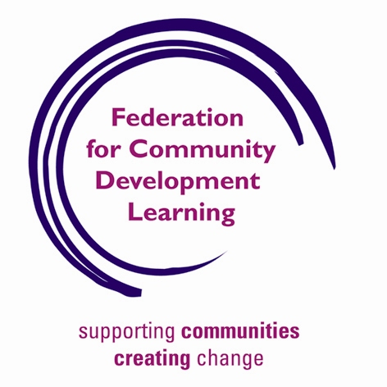

Join us to launch the Campaign for Community Development
at
Reading International Solidarity Centre (RISC): www.risc.org.uk
on
7th March 2011 from 1000 - 1500
These are difficult times for the community sector and community development as the pressure and effects of funding reductions and cuts begin to increase.
Community Development must re-establish itself as the challenging, innovative and liberating process that involves and supports individuals and communities to address their needs and fulfil their aspirations.
It is time for Community Development to both rediscover and re-assert its critical, independent stance and embody its values of equality, co-operation and social justice.
This is the start of the Campaign. We need your help to:
- Finalise and add to the Campaign documents.
- Plan the action
Also at this event, CDSE will launch:
- The final Report of the recent series of CDSE events on the Big Society: A view from the Community.
- A compilation of papers and other material entitled: A view from the South East, to be circulated widely and used to strengthen the voice of community development. (See below)
Book now for this free event and support this Campaign

Funded by: Every Voice Counts; The South East Empowerment Partnership & The Federation for Community Development Learning
Supported by:
National Coalition for Independent Action Communities Inc
English Regional Community Development Networks
CDX (Community Development Exchange)

Please apply and return this form to:

John Stevens, CDSE, 30 Mead End Road, Denmead, Hampshire PO7 6PZ
Tel: 023 9235 6936
E-mail to: equal.voices@ntlworld.com

Name: ………………………………………………………………………………..
Organisation: …………………………………………………..……………….............…

Contact Address: ………………………………………………………………….……………
………………………………………………………………
Tel: ………………………………...

Email: …………………………………………………..

Special requirements (access etc): ………………………………………….
………………………………………………………………………………………

Do you want display space? Yes No

Please use public transport if you can
Details of the RISC venue at: www.risc.org.uk

Workshop list below; highlight which one you would like to attend please:

- Mobilising the Community Development movement: Action planning for the Campaign.
- Building the links within and between communities: Cuts and inequalities: The Community Development contribution.
- Community Development and Community Organising.

A view from the South East
A South East Community Development take on the Big Society.
Community Development South East has recently undertaken a number of events across the South East as part of its work exploring the Big Society concept. A Report on those events: A view from the South East will be available soon.
CDSE is also collecting information about the effects of the current and on-going process of cuts and reductions in expenditure in the public, voluntary and community sectors.
CDSE would like to invite to you and your colleagues to submit written contributions about the opportunities and challenges which face community development across the South East.
The contributions should be no more than 5000 words and contain complete references where appropriate. Pictures from your project that illustrate your point can be included.
The focus of the contribution has to be community development related to one of the following issue areas:
Community Development: practice & policy
Democracy
Education
Employment/unemployment
Faith
Environment
Health
Housing
Recession & public sector and other cuts
Sustainability
The Big Society
Well-being
CDSE will compile your contributions together into a series of papers to be circulated widely and used to strengthen the voice of community development across the South East. This collection will be launched at a CDSE National Conference on 7th March. While CDSE will edit, collate and publish the material you will retain the copyright of your own work.
If you would like to contribute please indicate your interest asap to me; John Stevens at: equal.voices@ntlworld.com Please give your name, the topic area you want to write about and your location.
We would like you to submit the finished contribution by 25th February 2011 to the same address: John Stevens at equal.voices@ntlworld.com
This allows us time to edit and collate the material ready for the launch.

