The Campaign for Real Community Development and Independent Action
Big Society or just Big Cuts? | 
 | 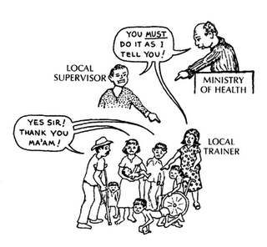
Monday 28th March 2011
9.00 a.m. - 1.00 p.m.
@ Directory of Social Change,
24 Stephenson Way, London NW1 2DP
Venue fully accessible
You need to book a place: Email matt@communitysectorcoalition.org.uk
Or Telephone 07827 258 411

We need to know numbers to plan the event, so let us know if you are coming
Agenda

9.00 a.m. Registration, Networking & refreshments
9.30 a.m. Setting the scene – scary icebreaker and announcements from Community Development Network London
10.00 a.m. Speakers presenting on CD, independent action and youth work followed by group debate
- John Stevens (Community Development Regional Network) – the Campaign for Real Community Development
- Janice Marks (Federation of Community Development Learning) – CD and occupational standards
- Andy Benson (National Coalition for Independent Action) – taking independent action
- Speaker tbc (Campaign to Defend Youth Work) – The value of youth work and community action
11.00 a.m. Comfort break

11.15 a.m. Group work: what are the issues you want to take action on? What are the campaigns you want to connect with? What is the one thing CDNL must do in 2011?

12.15 p.m. Plenary / ways forward

12.30 p.m. Lunch and networking

Objective for the day:
- Understanding what is going on: What are the issues that the campaign for real community development, the campaign to defend youth work and the national coalition for independent action are organising on and how you can get involved

Map and directions

By rail:
Euston: (also 10mins from Kings Cross/ St Pancras)
Leave Euston station by the exit at the side of the ticket office. Go over the zebra crossing to Euston Street. Stephenson Way is the first left.

By tube:
Euston: Northern, Victoria lines
Euston Square: Circle, Hammersmith & City, Metropolitan lines
Take right hand exit and turn right to bring you to North Gower Street. Stephenson Way is first right.
Warren Street: Northern, Victoria lines

By bus:
10, 18, 24, 27, 29, 30, 73, 88, 134

London Transport Information telephone:
020 7222 1234

Disability Access:
The building is accessible for wheelchairs
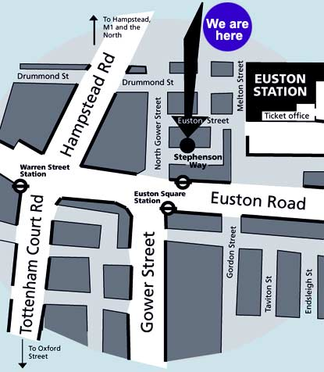

http://www.dsc.org.uk/Search/ContactUs/Mapsanddirections

