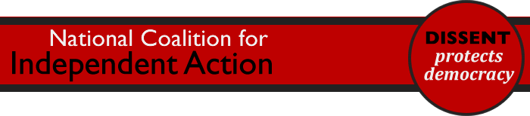
Charities may be prepared to break law over Lobbying Act
Charities and other voluntary groups have been urged to consider breaking the law by defying the requirements of the Lobbying Act. The new legislation, nicknamed the Gagging Act, will restrict charities' expenditure on campaigning and limit their ability to speak up for the people they exist to serve. The new law is framed in such a complex way that many charities will censor themselves for fear of falling foul of the restrictions.
Now that the campaign inside Parliament has been lost, the National Coalition for Independent Action (NCIA), which works to uphold the independence of the voluntary sector, is asking charities and NGOs to commit to civil disobedience when the new law begins to have an impact.
Over 130 voluntary groups, including large mainstream charities such as Oxfam and the British Heart Foundation, campaigned against the bill. NCIA is asking them to follow through on their opposition and defy these unjust limits on free expression.
Andy Benson, co-director of NCIA, said:
"Charities and other voluntary groups serve the needs of their members, supporters and service users. Millions of people will lose out if voluntary groups are prevented from speaking about people's needs.
"Civil disobedience should not be done lightly but it is sometimes a fair response to an unfair law. We are asking charities and other groups to say they will be willing to break the Gagging Act if this is needed to serve the people for whom their organisations exist."

ENDS
Notes
- The National Coalition for Independent Action (NCIA) is a growing network of individuals and groups working to promote civil society and civil action, free from government or corporate control. NCIA is made up of national and local groups, front line services, campaigners and local activists, academics, policy and other commentators, professionals, trades unions and people working in public services.
- The Transparency of Lobbying, Non-Party Campaigning and Trade Union Administration Act was passed on 30th January 2014. It will come into force in September 2014. Part 2 of the Act introduces restrictions on campaigning and expenditure by civil society organisations in the period before a general election is held. Critics say that it does little if anything to restrict the activity of corporate lobbyists, which was the government's original stated aim.
- For more information or to interview a director of NCIA, please call Symon Hill on 07920 037 719.

